**Assignment 6 - R practice**

50 points.

For this assignment you will be using RStudio. Make sure to watch the lecture on the Introduction to R for installation instructions.

I would like you to do the following:

* ~~Create a new R notebook for this assignment.~~
* ~~Choose 4 different datasets in R (use data() to see available datasets).~~
* ~~Choose 1 CSV/XLS/XLSX file and load it into RStudio (Use any file you like. You can use the files you used for the last assignment if you wish).~~
* ~~Run the summary function on each dataset you chose and for the imported CSV/XLS/XLSX file.~~
* ~~Show the second quantile for a column in your dataset and for the imported CSV/XLS/XLSX file.~~
* ~~Choose an appropriate plot/graph (scatter, line, bar, pie) and plot data from your dataset and for the imported CSV/XLS/XLSX file.~~
* ~~Create a pie chart at the end illustrating the distribution of graphs/plots you used. I.E. each "slice" should represent a graph type.~~

**Deliverables -**

* A .doc file with the following:
  1. Names of the datasets you chose
* 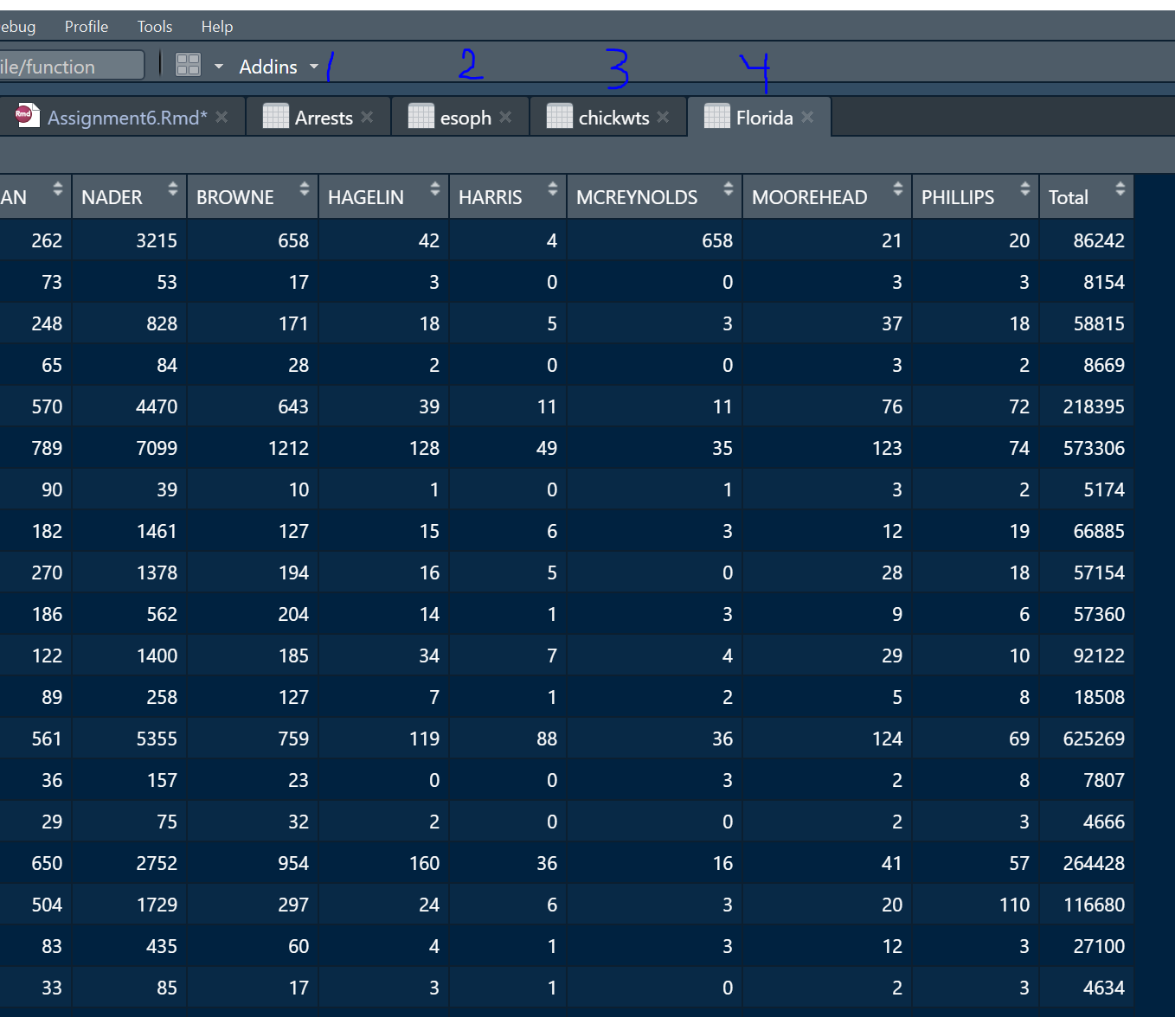
  1. File name and Screenshot of your imported csv/xls/xlsx in RStudio
* 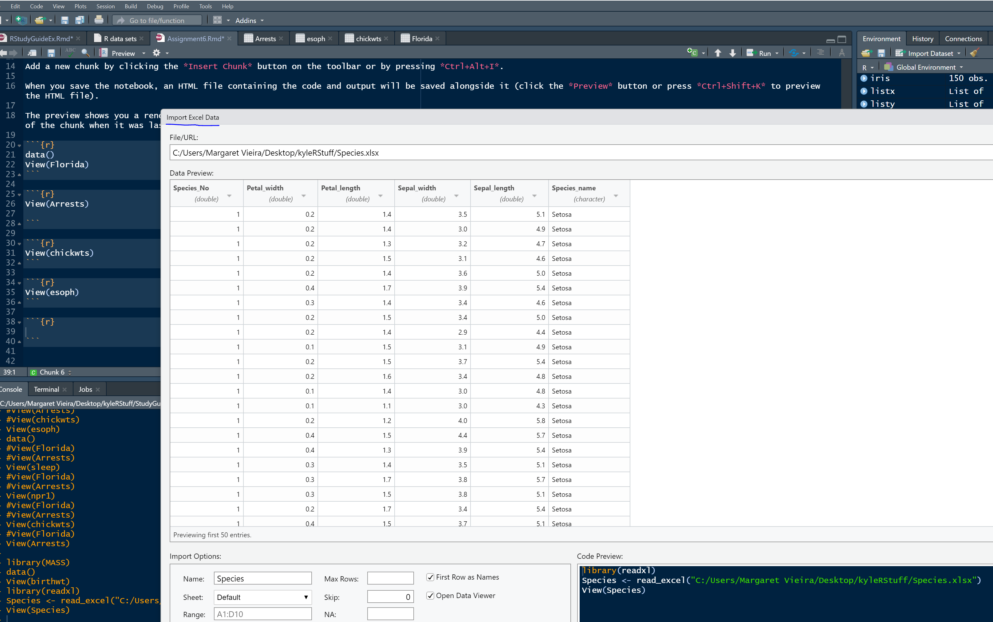
  1. Screenshots of the summary output
* 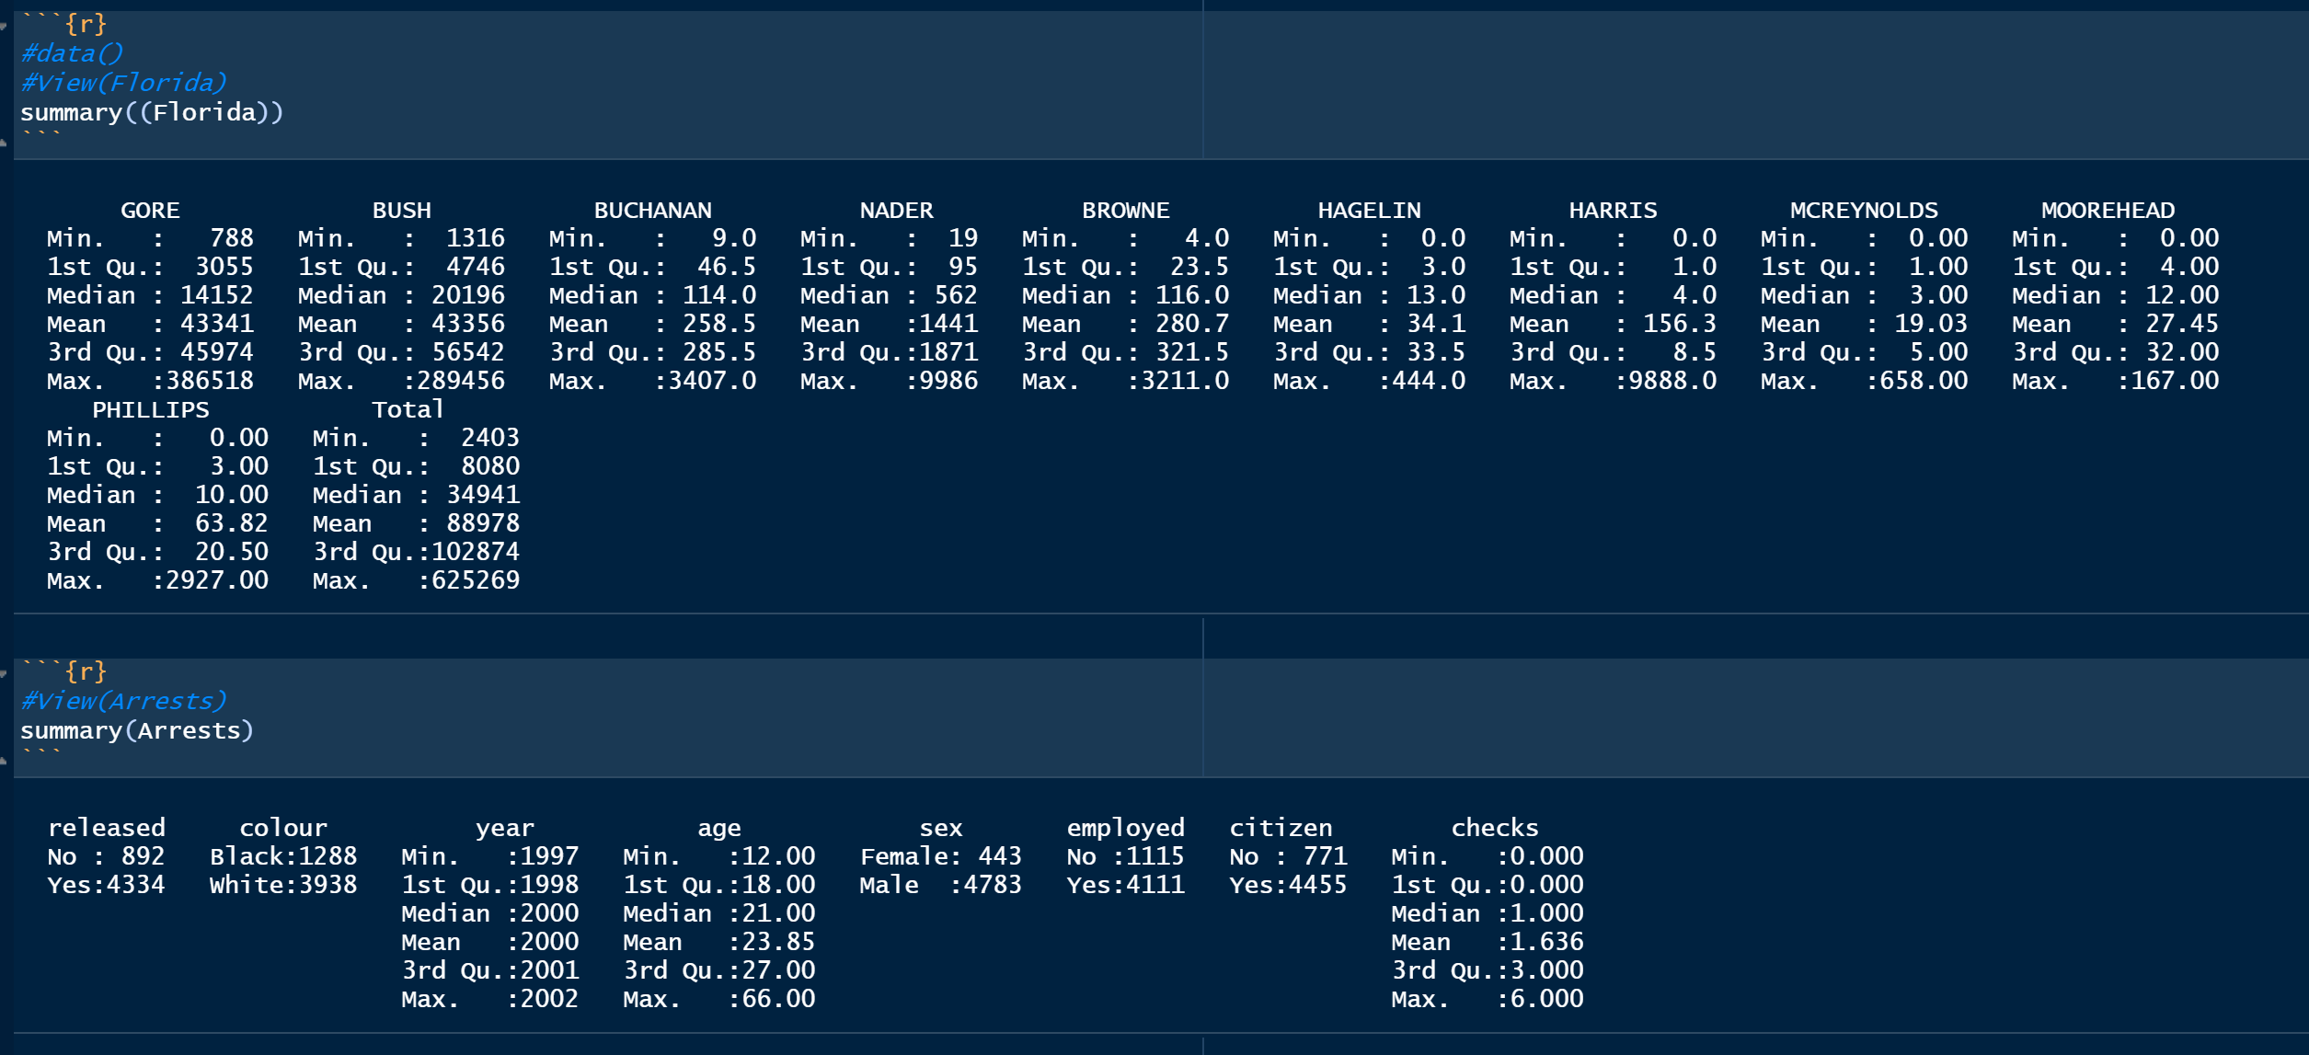
* 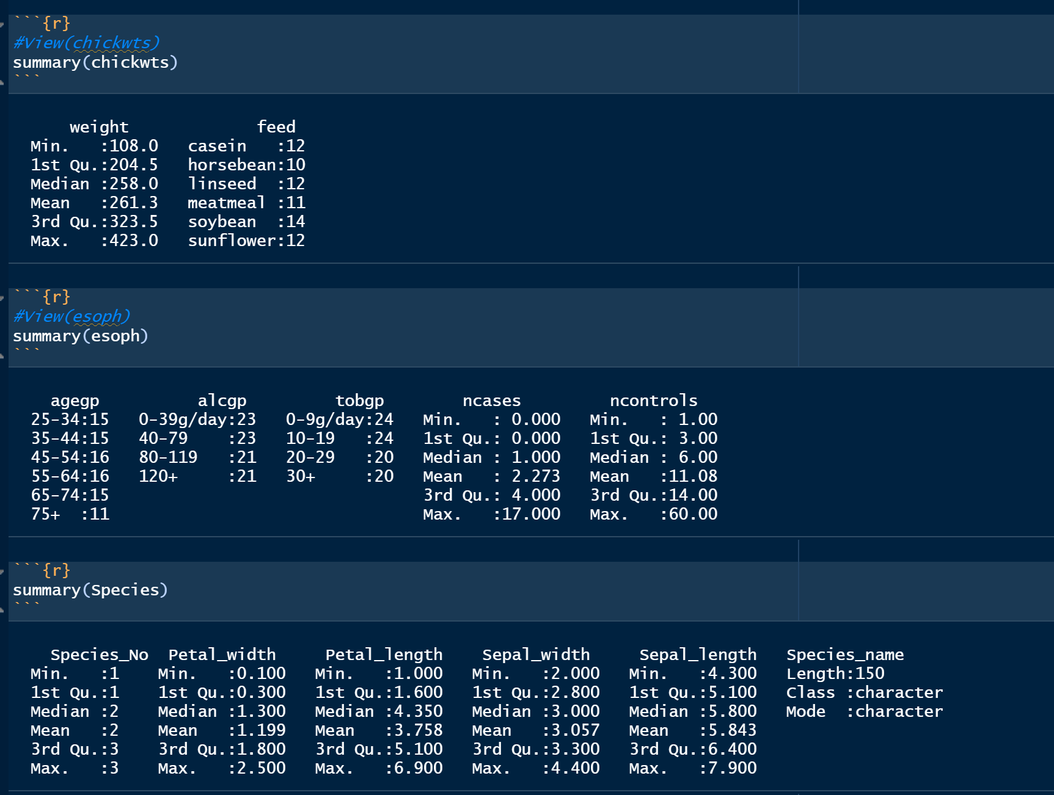
  1. Screenshots of the quantile result
* 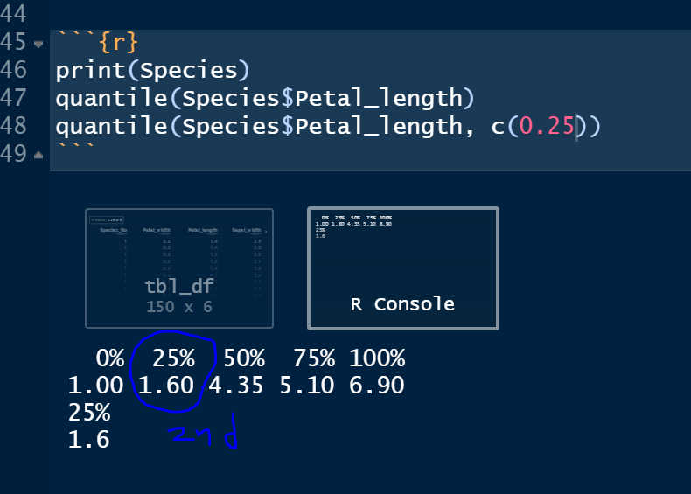
  1. Screenshots of the graphs/plots for each dataset
* 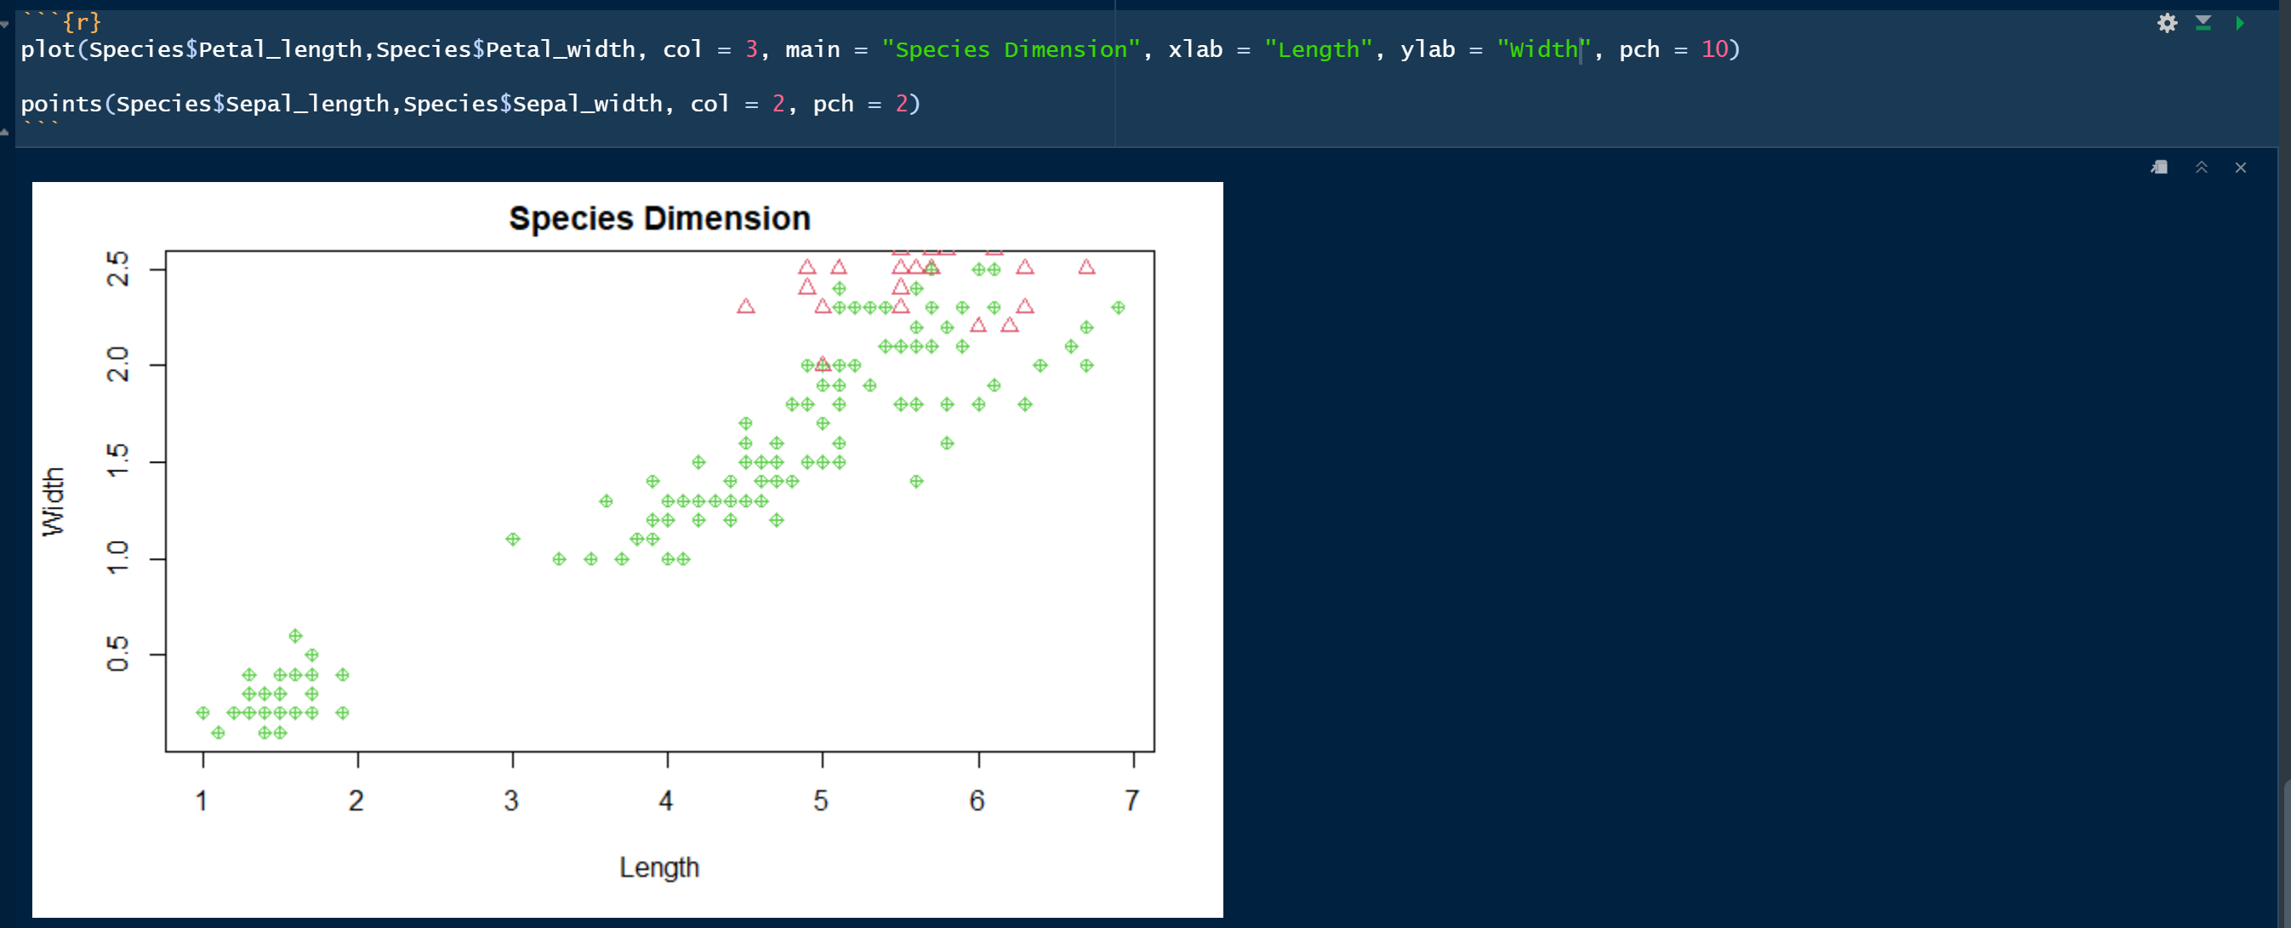
* 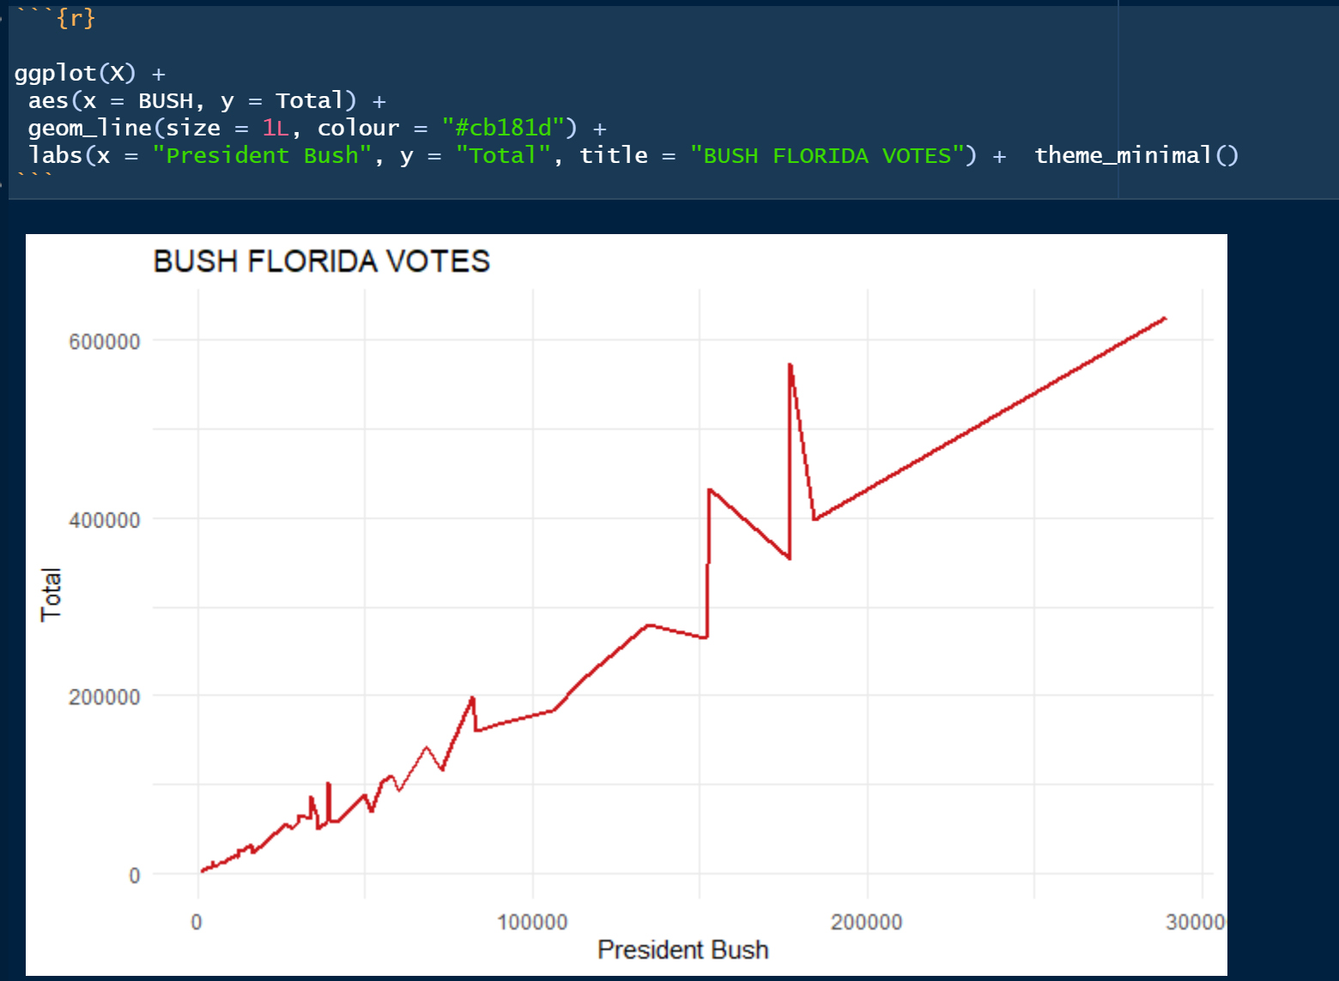
* 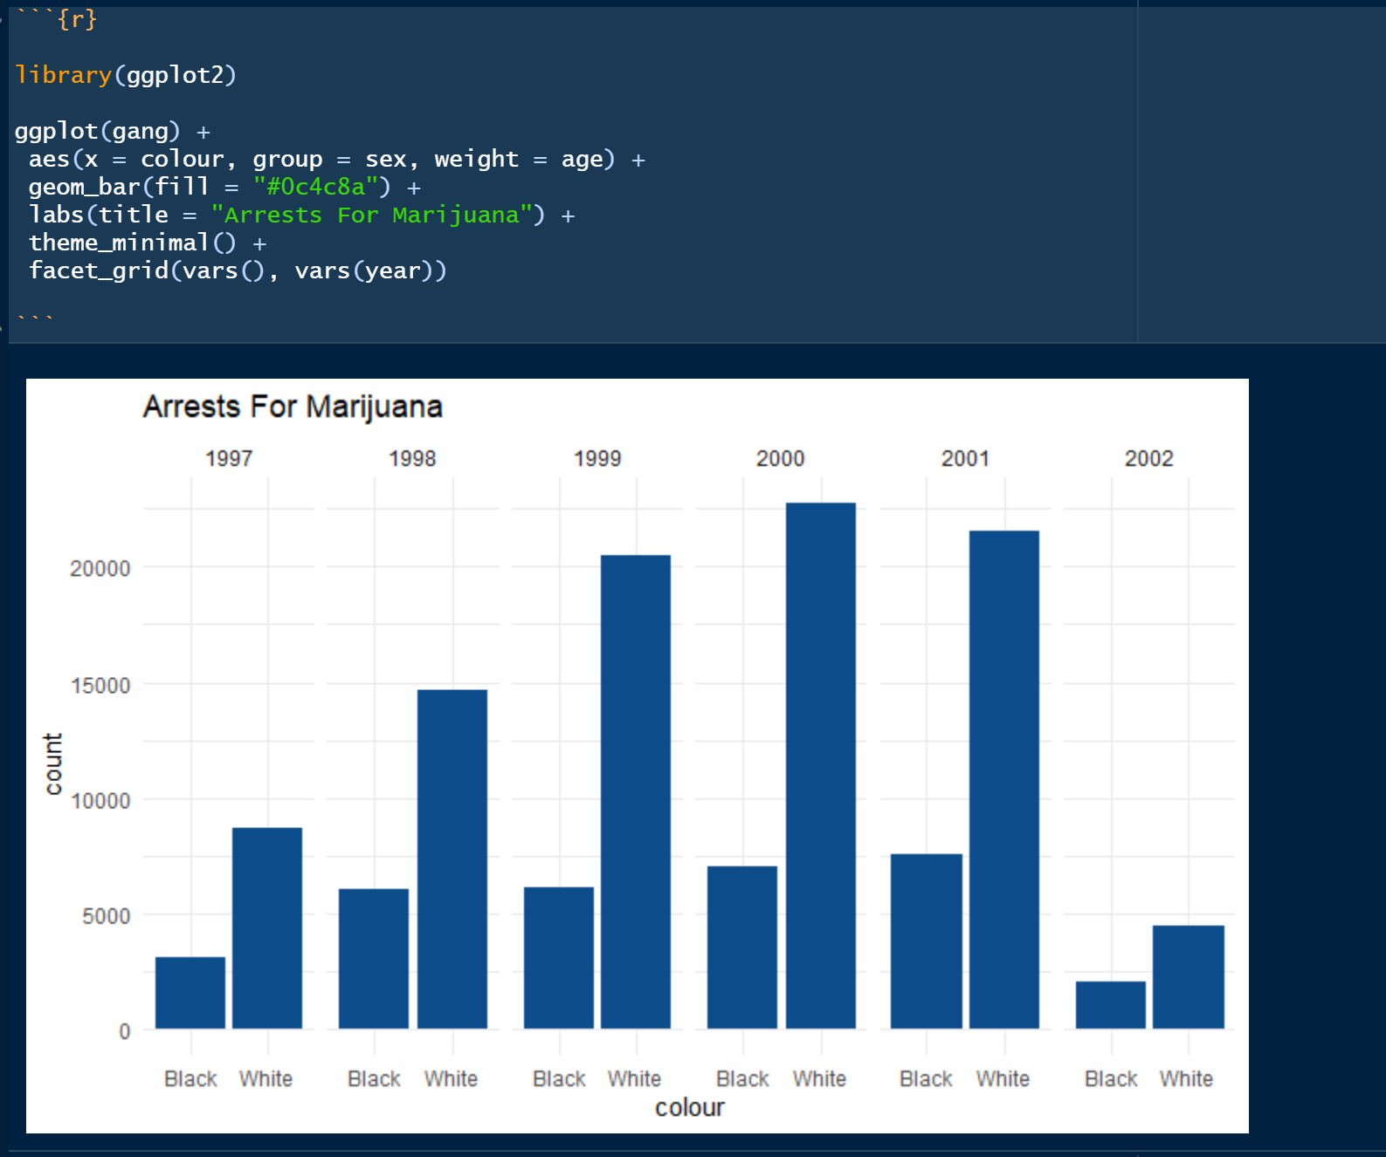
  1. Screenshot of the pie graph.
* 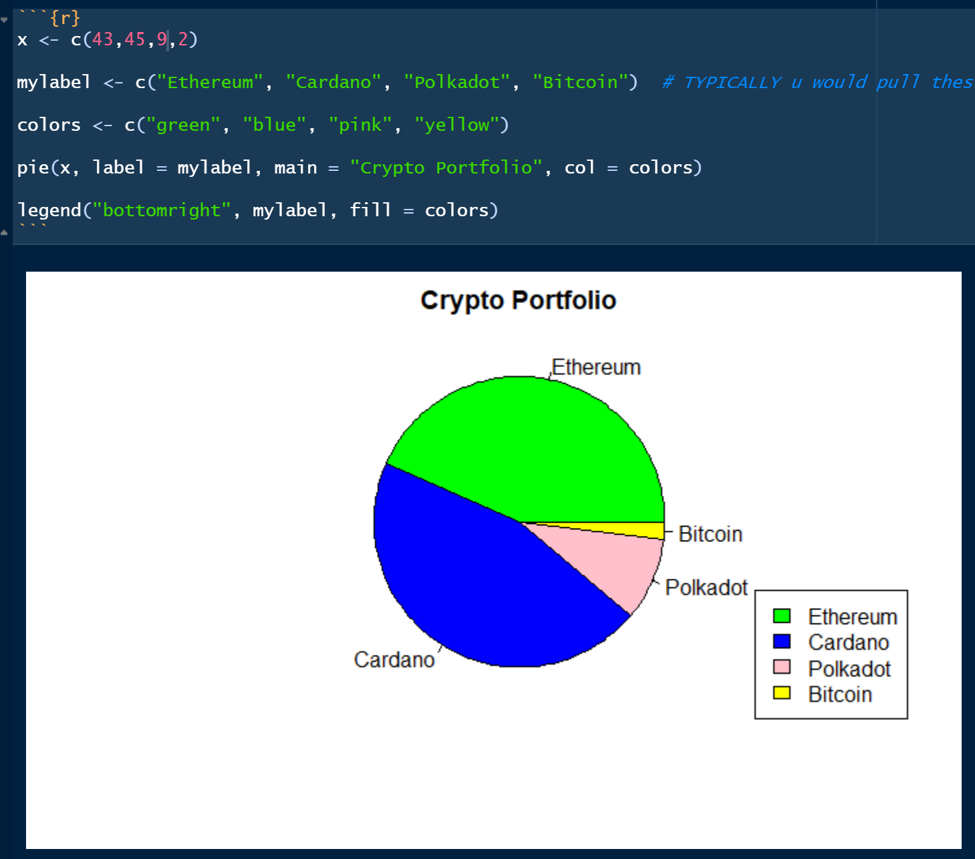
* A copy of the CSV/XLS/XLSX file you used.
* A copy of the HTML file generated by your R notebook.